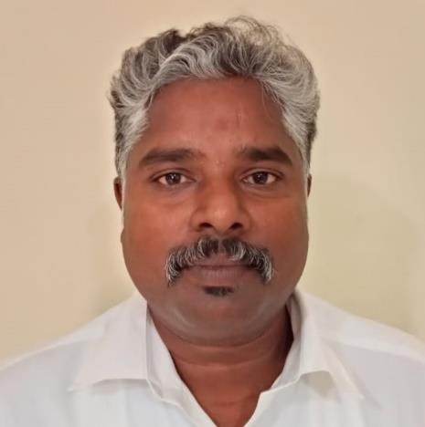

RAJAN.K.G

OBJECTIVE

CURRICULUM VITAE

Tel No. (M) +91- 98435 01588, E-mail : kgrajan.siva999@gmail.com

To be a part of an establishment which provides a high quality of work, through challenging Opportunities and a meaningful career growth.

AREA OF SPECALIZATION

- Food production department (Indian, Chinese, Continental and Tandoori)
- Bakery and Confectionary
- Specialized in CARVING (Vegetable, Ice and Butter)

ACADEMIC CHRONICLE

Degree | University/College/School | Year of Passing | Class
B.H.M., (Bachelor of Hotel  Management) | J.J. College of Arts & Science, Bharathidasan University, Pudukkottai. | 2001 | I Class

M.T.M., (Master of Tourism  Management) | DDE, Madurai Kamaraj University | 2007 | II Class
M.Phil in Hotel Management &  Tourism | Bharath College of Science and management | 2016 | I Class

EMPLOYMENT RECORD AND EXPERIENCE

Designation | Institution & Place of posting | Period
Assistant Professor | Jamal Mohamed College, Trichy | June 2019 – till date
Asst Prof and Head of the Dept. | Pavender Bharathidasan College of Arts & Science,  Trichy | Aug, 2003 to Aug,2019
Commis de cuisine | Quality Inn Residency,  Hyderabad | Mar, 2002 to Feb,2003
Commis de cuisine | Taj Fisherman’s Cove,  Chennai | Oct,2001 to Feb,2002
Commis de cuisine | Best Western Ramanashree,  Mysore | Jun,2001 to Sep,2001

PROFESSIONAL EXPERIENCE

- Courses Handles – BSc. (Hotel Management & Catering Technology)

  - Importance of Food Safety and Hygiene
  - Tutored Basic Food Production
  - Bakery and Confectionary (Theory & Practical)
  - Impart Food and Berverage Service
  - Front Office Management

Workshop Organized and attended

  - Integral part of the team that conceptualized and produced the “Food Festival” Organized at Pavender Bharathidasan College of Arts & Science, Trichy-2003 to 2009.
  - Participated and presented the oral paper on “Development of functional bakery products for food security in India” in INCOFTEC Edition II – 2010 at IICPT, Thanjavur

External Evaluation – BSc. (Hotel Management & Catering Technology)

  - Bharathidasan University
  - SRM University

  - MGR University

Additional Responsiblities

  - Academic Coordinator
  - Students Welfare Coordinator
✓

PROFESSIONAL TRAINING EXPERIENCE

S.No | Organization | Duration | Details of Training
1. | Hotel Sangam, Thanjavur | 20th May 1999 to 20th July 1999 | Industrial Training on Food Products  Production
2. | King’s Park Chennai | 15th Dec 1999 to 25th Jan 2000 | Industrial Training on Bakery and  Confectionery
3. | The Central Court Hotel, Hyderabad | 15th Dec 2001 to 15th Jan 2002 | Industrial Training on  Food Products Production
4. | Certificate course | 1998 | Diploma course in  Computer Application

PERSONAL DETAILS

Name : RAJAN.K.G

Father’s Name : Gunasekaran.K
Date of Birth : 10.06.1980

Gender : Male

Marital Status : Married

Nationality : Indian
Language Known : Tamil & English Address for Communication : Vallathirakottai,
Alangudi TK, Pudukkottai Dt – 622 303, Tamilnadu, India.
Tel No. (M) +91- 98435 01588

E-mail : kgrajan.siva999@gmail.com

DECLARATION

I hereby declare that all the statements made in this Curriculum Vitae are true and complete to the best of my knowledge. I assure that I shall discharge my duties perfectly and honestly to the entire satisfaction of my superiors in case I am appointed in Your esteemed institution. I shall also abide by the rules and regulations of your institution.
Station : Pudukkottai

Date : Yours Sincerely,

(RAJAN.K.G)

